Thursday, January 10, 2019

CHAPTER 12

P.P.12.1 For the abc sequence, leads by 120 and leads by 120.

Hence, V
110∠–90˚V

P.P.12.2
207.8∠60˚V

Alternatively, using the fact that leads by 30 and has a magnitude of times that of ,
207.8∠60˚V

Following the abc sequence,
207.8∠–60˚V
207.8∠±180˚V

Following the abc sequence,
3.75∠111.34˚A

P.P.12.3
The phase currents are
6∠–60˚ A

6∠–180˚ A

6∠60˚ A

The line currents are
10.392∠–90˚ A

10.392∠150˚ A

10.392∠30˚ A

P.P.12.4 In a delta load, the phase current leads the line current by 30 and has a magnitude times that of the line current. Hence,
5.548∠65˚ A

120∠98.69˚ V

P.P.12.5

After converting the -connected source to a Y-connected source,

7.21∠+173.66˚ A

P.P.12.6
For the source,
–(1.054.2 – j843.3) VA

For the load,

where

(1012 + j801.6) VA

P.P.12.7

Alternatively,
,

= 46.31 A

P.P.12.8
- For load 1,

For load 2,

S = S₁ + S₂ = 56.47 + j47.29 kVA

with

For each capacitor, the rating is

- At unity pf,

P.P.12.9
The phase currents are
= 35.2+j17.595

= 5.263+j43.68

The line currents are
I_{a} = I_{AB} – I_{CA} = (35.2+j17.595) – (5.263+j43.68)
= 29.94–j26.08 = 39.71∠–41.06˚ A.
I_{b} = I_{BC} – I_{AB} = –48.95–j41.42 = 64.12∠–139.8˚ A.
I_{c} = I_{CA} – I_{BC} = 19.013+j67.5 = 70.13∠74.27˚ A.

P.P.12.10
The phase currents are

The line currents are

42.5∠–135° A

The real power is absorbed by the resistive load

P.P.12.11 The schematic is shown below. First, use the AC Sweep option of the Analysis Setup. Choose a Linear sweep type with the following Sweep Parameters : Total Pts = 1, Start Freq = 100, and End Freq = 100. Once the circuit is saved and simulated, we obtain an output file whose contents include the following results.

FREQ | IM(V_PRINT1) | IP(V_PRINT1)
1.000E+02 | 8.547E+00 | -9.127E+01

FREQ | VM(A,N) | VP(A,N)
1.000E+02 | 1.009E+02 | 6.087E+01

From this we obtain,

,
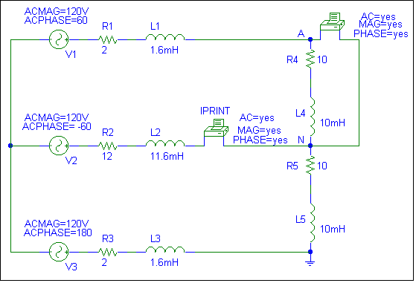
P.P.12.12 The schematic is shown below.
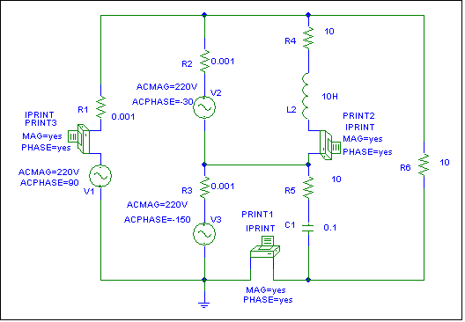

In this case, we may assume that , so that . Hence, and .

Use the AC Sweep option of the Analysis Setup. Choose a Linear sweep type with the following Sweep Parameters : Total Pts = 1, Start Freq = 0.1592, and End Freq = 0.1592. Once the circuit is saved and simulated, we obtain an output file whose contents include the following results.

FREQ IM(V_PRINT1) IP(V_PRINT1)
1.592E-01 3.724E+01 8.379E+01

FREQ IM(V_PRINT2) IP(V_PRINT2)
1.592E-01 1.555E+01 -7.501E+01

FREQ IM(V_PRINT3) IP(V_PRINT3)
1.592E-01 2.468E+01 -9.000E+01

From this we obtain,

I_{AB} = 15.55∠–75.01˚A

P.P.12.13
- If point o is connected to point B,
13.175 kW

where

29.91 kW

- Total power is = (13.175+29.91) kW = 43.08 kW.

P.P.12.14 , ,

- 2.356 kVAR

(lagging / inductive)
It is inductive because
- For a Y-connected load,
,

The impedance is inductive.

P.P.12.15

The equivalent Y-connected load is

0.8021 kW

